**CI/CD**

**LAB EXPERIMENT 9**

**SUBMITTED BY:**

NITISH KUMAR SINGLA

500071913

R171218126

**SUBMITTED TO:**

HITESH KUMAR SHARMA SIR

**Uploading Artifacts on Nexus Server using Command Line**

* Install Nexus
* Go to cmd, enter nexus directory and run command **nexus.exe /run**

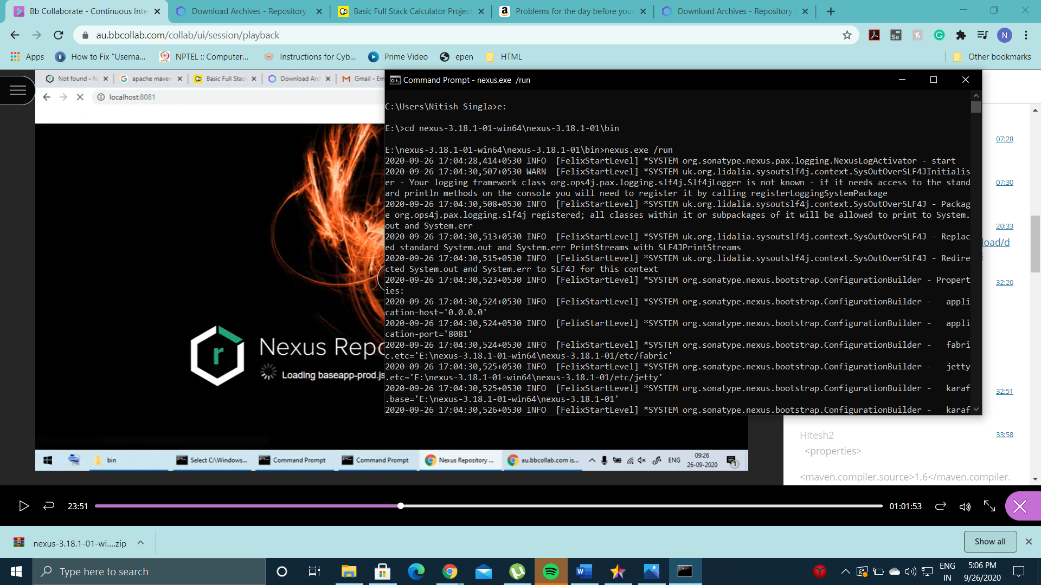

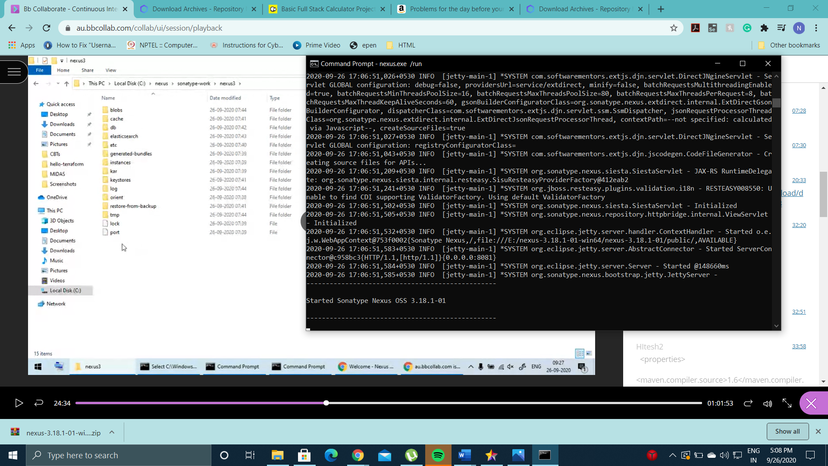

* Go to localhost:8081 to land on Nexus Server

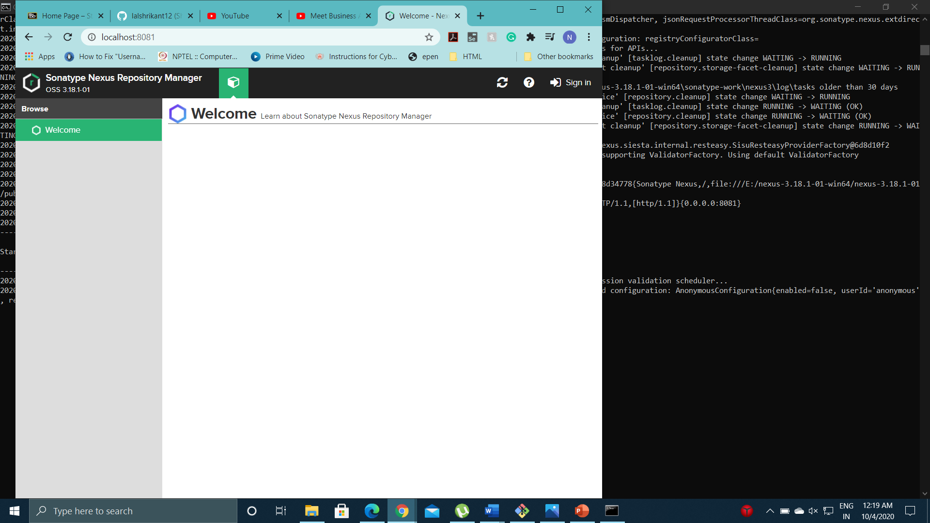

* Open admin.pasword folder to get password for first time authentication

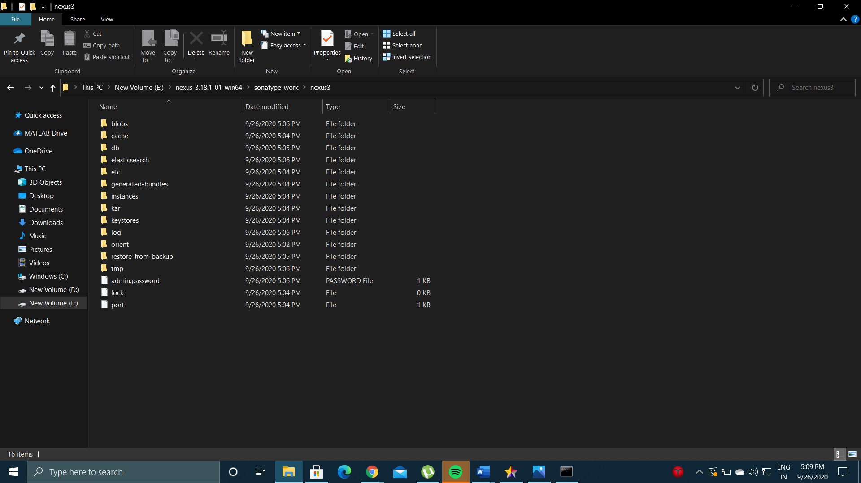

* Go to repositories and click create repository and click on maven2 (hosted)

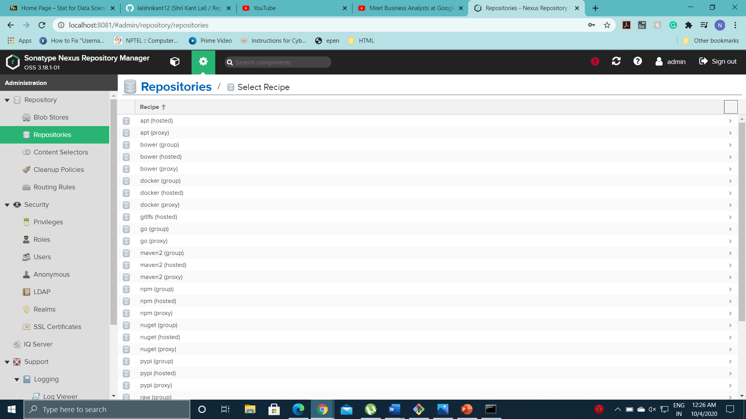

* Enter Repsoitory name, set artifact type to Snapshot, and set deployment setting to allow redeploy and create repository

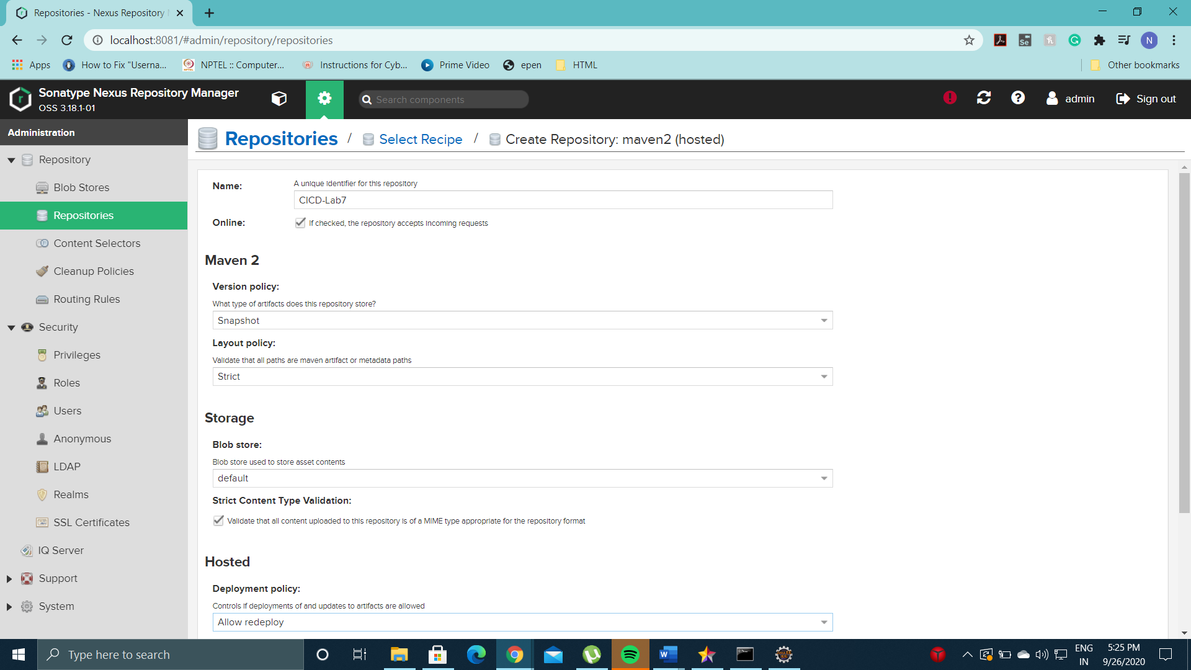

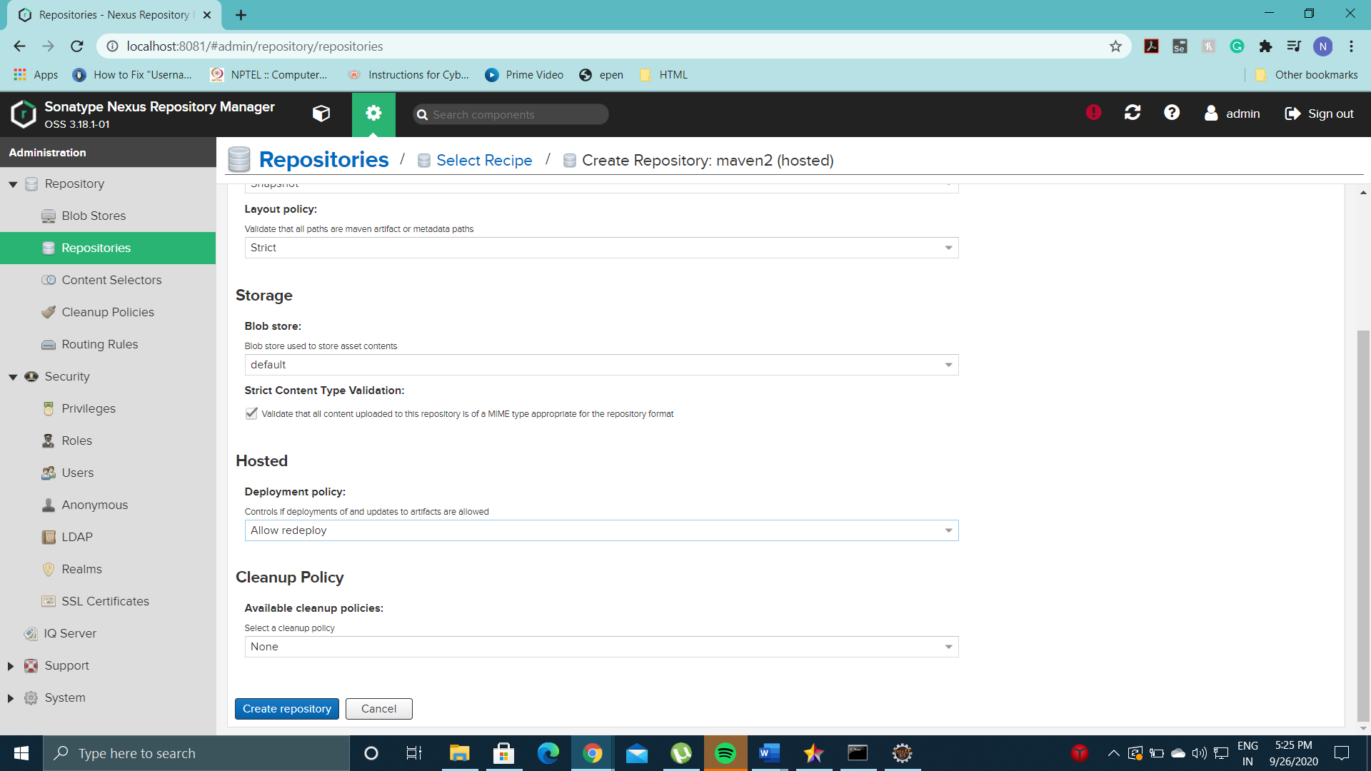

* See the created repository in the list of repositories

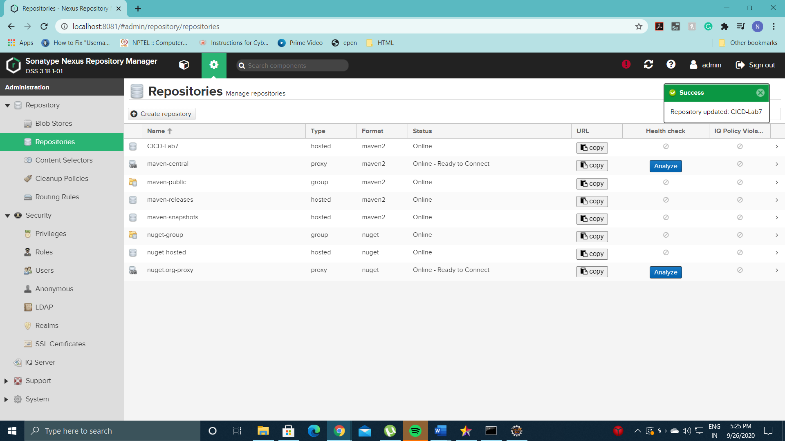

* Go to Apache-Maven Settings.xml and create a nexus server under server tag. This is done to integrate Maven with Nexus.
* Add id name same as the nexus repository name. Add username and password of your nexus server.

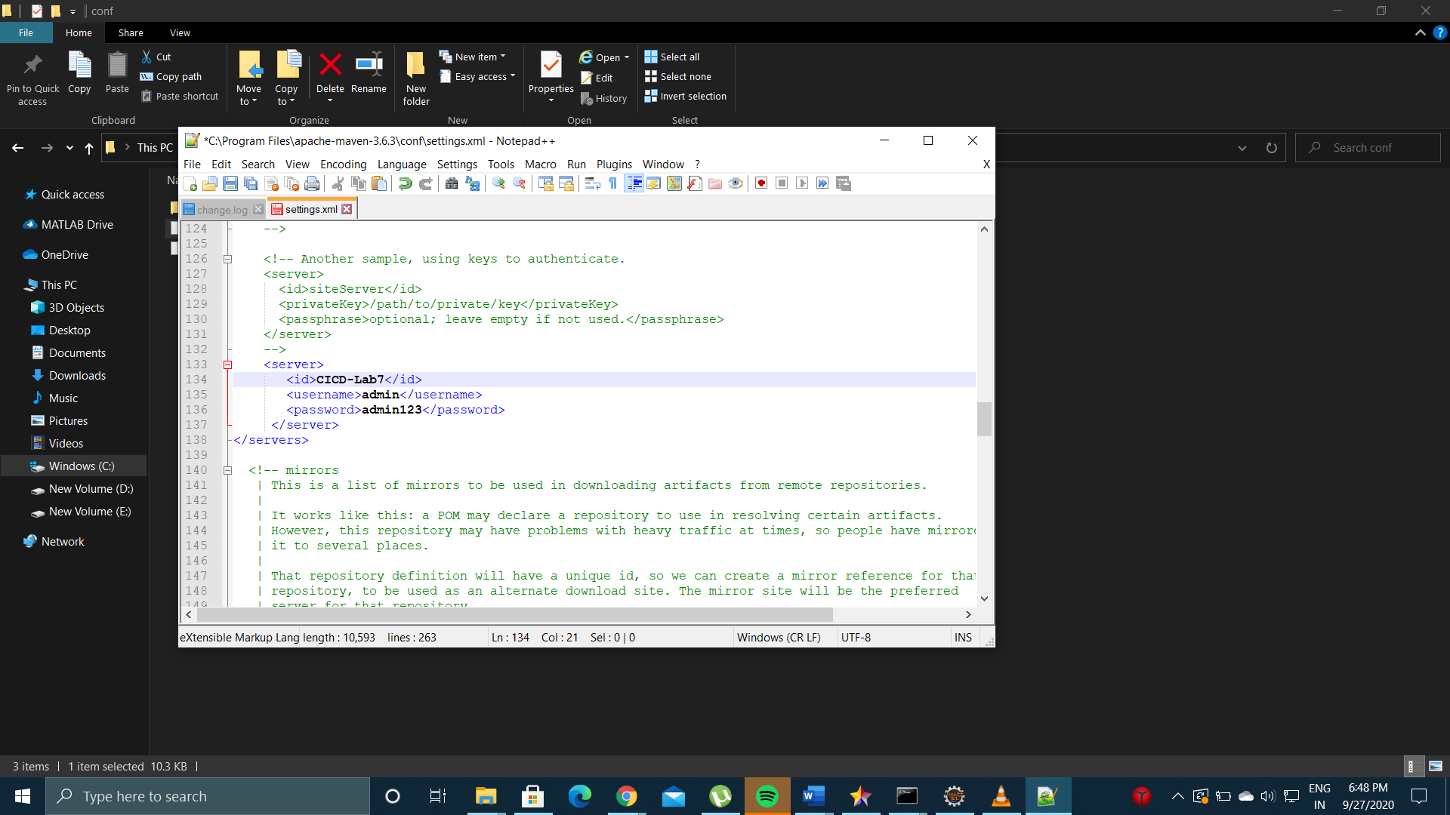

* Create a Maven Project and add a distributionmanagement tag in pom.xml to deploy the project to the Nexus Repository.

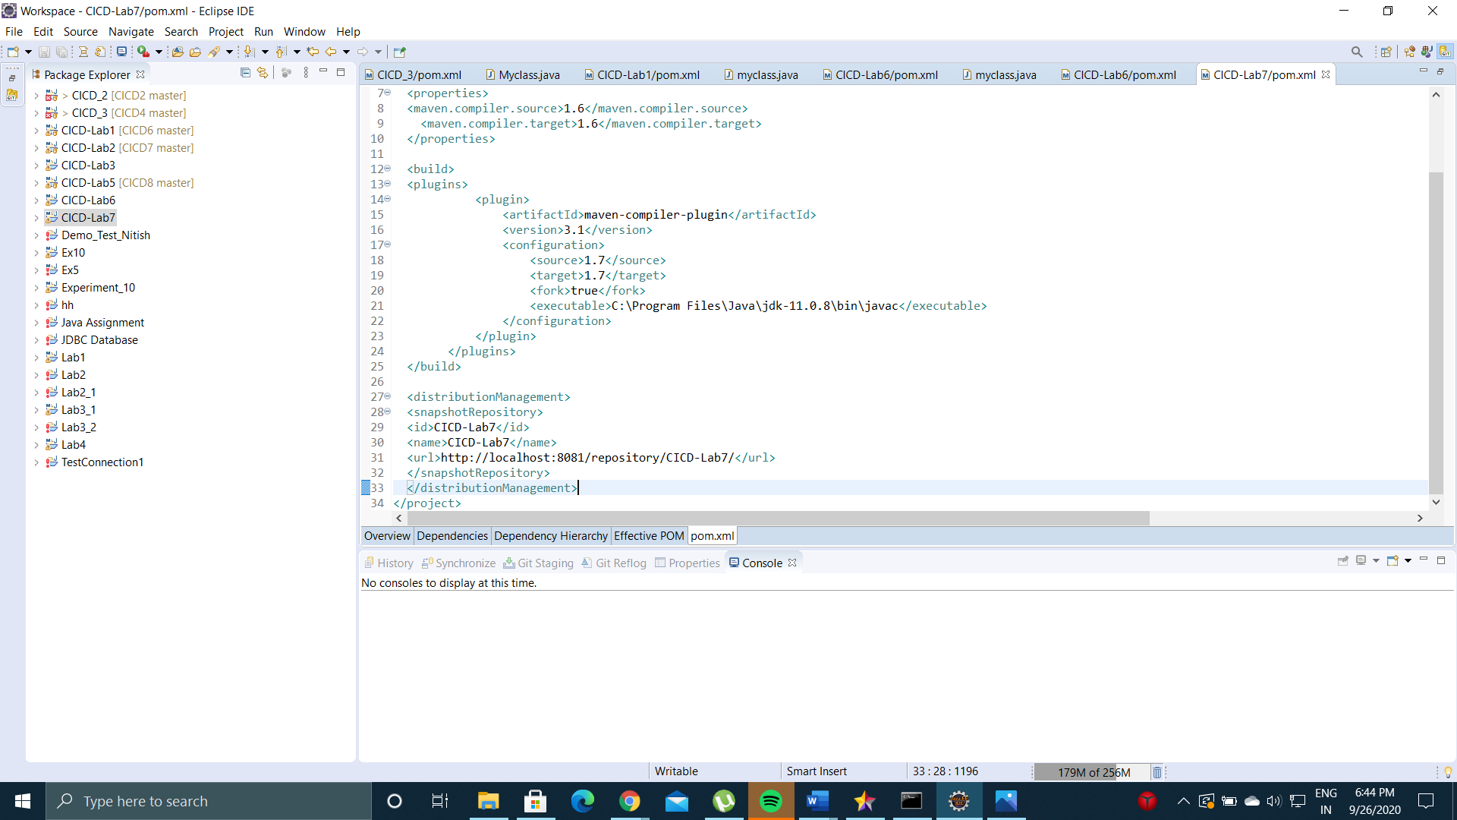

* Run command mvn deploy to deploy the build of the maven project.

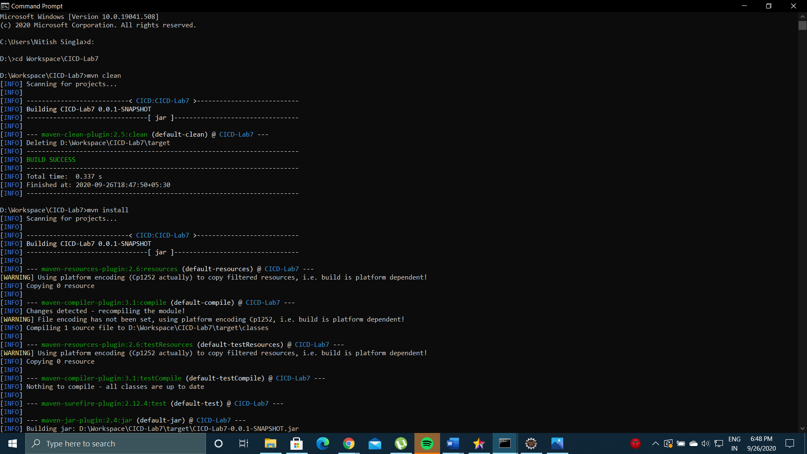

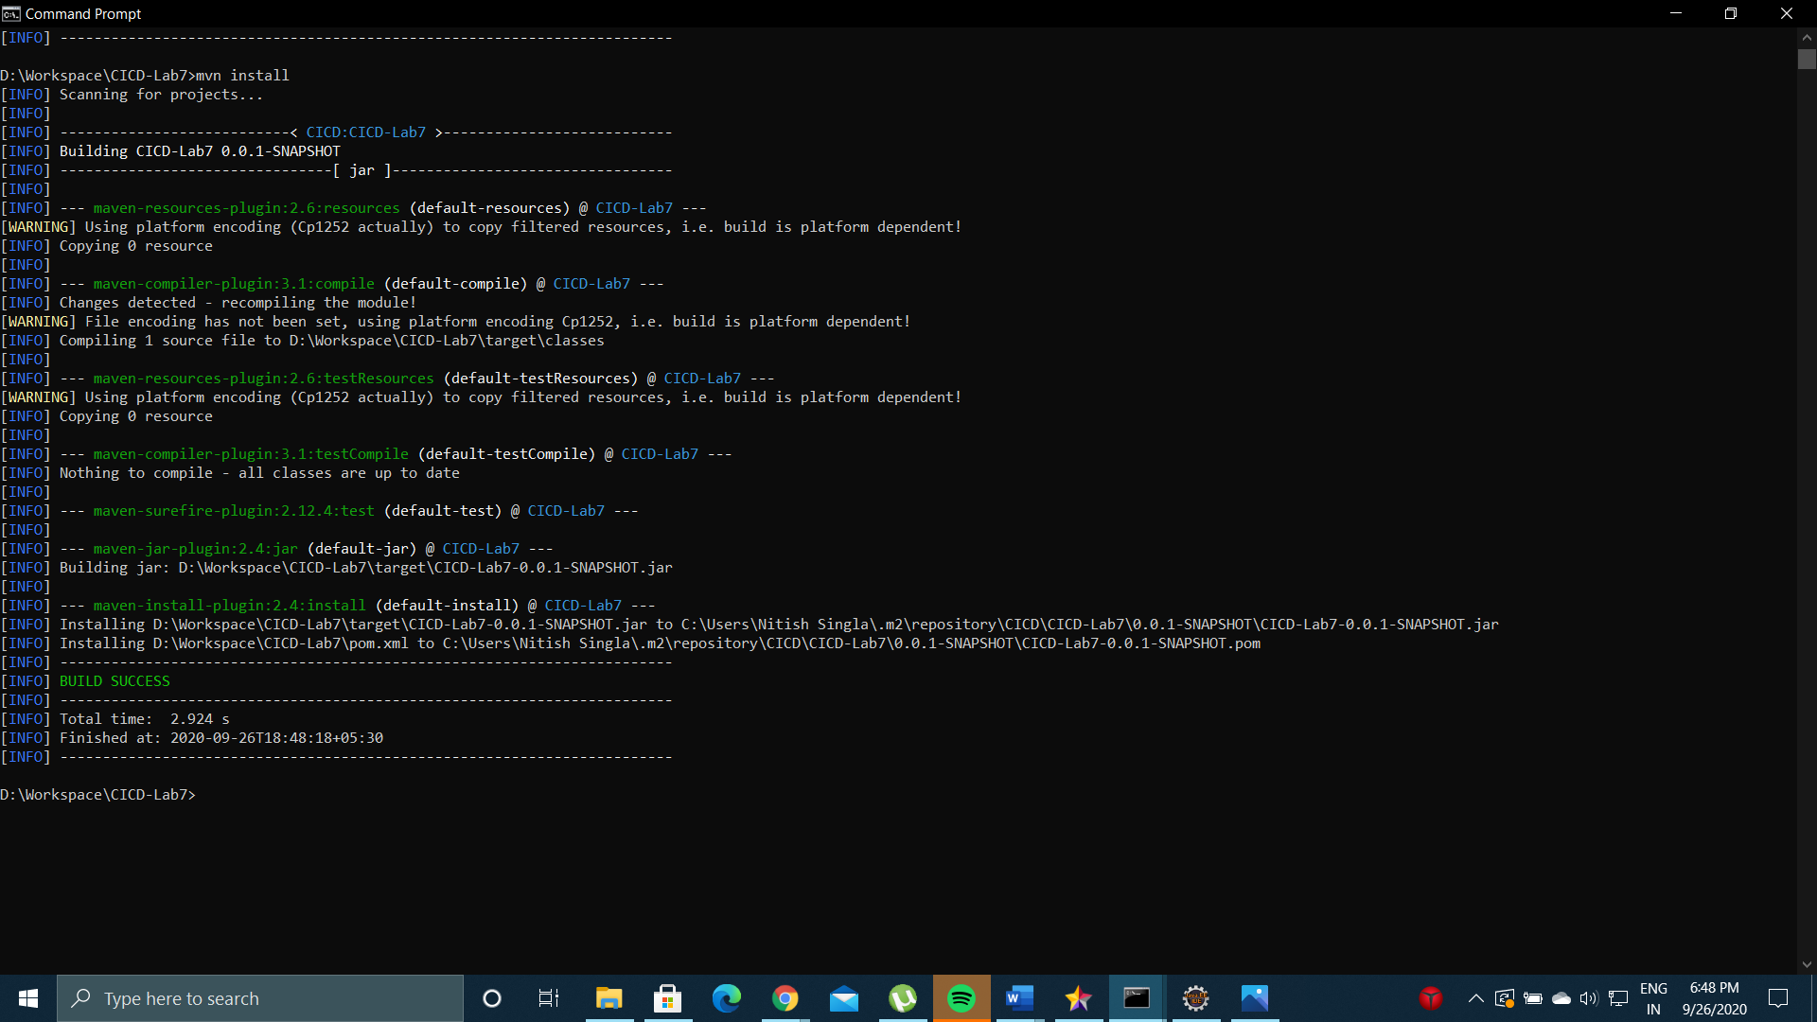

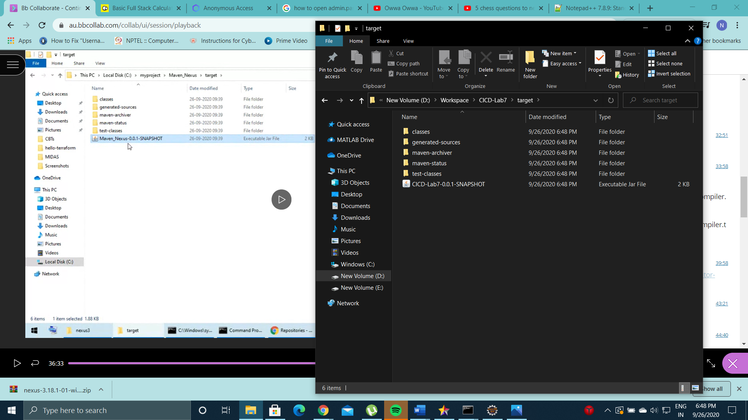

* mvn deploy

